The Coalition of Texans with Disabilities

2022 Annual Summary

December 8, 2022

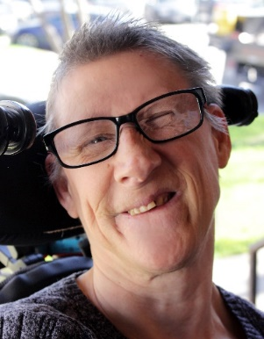
2022 was tough, yet I’m proud of CTD’s accomplishments. We took some crushing blows—the loss of our colleague and friend, Susie Angel (right), the most painful among them. This report, and our work in the coming months, particularly on attendant wages, access to dental care, voting and disability arts, is dedicated to her. We think she’d be proud as well.

Read our full tribute to Susie at txdisabilities.org.

Below, find a 4-page summary of our work in 2022. We hope you will stay engaged with us as the 88th Legislative Session gets underway.
For a barrier-free world,
Dennis Borel
CTD Executive Director

Major Advocacy Work in 2022
The Legislature did not meet this year, but the time to set the table for positive advocacy was there and we seized the moments. We built on foundations laid last session and took advantage of opportunities to prepare ourselves and our membership for the session ahead.

Community Services and Supports
After a lackluster session for attendant wages in 2021, a lot has happened on this issue. To start, CTD led actions to correct Texas Health and Human Services Commission (HHSC) rules that would have excluded 130,000 attendants from eligibility for American Rescue Plan Act (ARPA) bonuses. Now, those attendants will receive $238M in extra bonuses.

“The discrepancy was uncovered this month by dennis borel, an advocate who heads the austin-based coalition of texans with disabilities…”
Texas Got Millions to Boost Pay for Strapped Healthcare Attendants. It Left out the Largest Group.
Houston Chronicle, April 21, 2022.
Looking ahead to a more permanent solution in the Legislature, CTD will be pushing to raise base attendant wages from $8.11 to $15 in the first year of the next biennium and $17 in the next, with a mechanism that would help keep pay rates up with inflation.

We’ve already begun advocating for this needed change. In 2022, we:
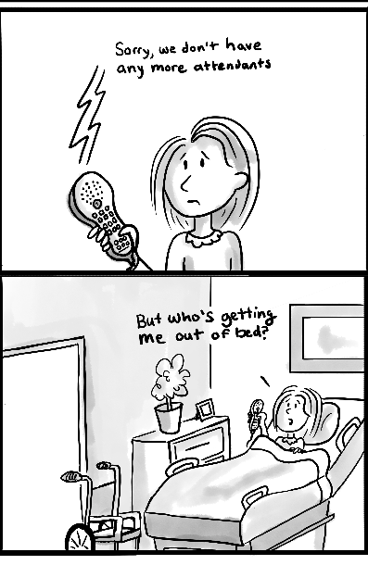
- published Crushing the Workforce 2.0 (right), a data driven updated report on the community attendant care crisis. View it online at txdisabilities.org/about-us/reports.
- collaborated with Texas Health Institute on an economic analysis on increasing attendant wages that demonstrates savings in hospitalizations and nursing home admissions and increases in state sales tax revenue (to be released).
- monitored the HHSC appropriations request to ensure it included funding for attendant wages and interest list reduction (it did).
- given both public and invited testimony in 4 legislative hearings and met with multiple key offices.

Voting Rights and Elections
We knew at the close of 2021, with the passage of voting restrictions, that we had a fight ahead of us. We’ve been monitoring the new legislation (rollout has been troubled) and seeking opportunities to resolve its problematic provisions. In addition, we are currently setting meetings for a bill sponsor to address accessible mail-in ballots in 2023.
Outside of the Legislature:
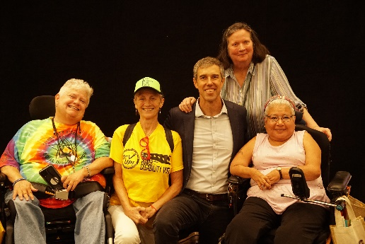
- We won an emergency judge’s order in Bexar County requiring mail-in ballots accessible to people with visual impairments for the November 8 election.
- CTD and REV UP Texas were the principal organizers of the Texas Disability Issues Forum, the state’s preeminent disability policy election event, on September 19 (right, candidate for Governor Beto O’Rourke with Austin disability advocates), with a live audience of 200+ and dozens of watch parties throughout Texas. Four top-of-the-ballot state candidates gave one-on-one interviews in the state’s preeminent disability policy election event—an accomplishment unmatched across other Texas industries.
- In August, we were the only disability organization invited to give two presentations on accessibility in voting at the Secretary of State’s Election Law Seminar.

Children and Education
Texas’ public systems that serve children are falling short in many ways, and children with disabilities are taking some of the hardest hits. CTD advocacy team members spent this year drafting comments, training parents and families, organizing events, and not letting those state agencies off the hook for their short comings. We’ve been involved in a number of positive developments that we’ll work hard to pass this session:

- In 2021, some of the bills we worked on did not make it through the legislative process, despite broad support. We’re enthusiastic that Reps. Mary Gonzalez and Alma Allen are refiling their Inclusive Child Care bill and Early Pickups bill, respectively.
- Also from the 2021 session, the Texas Legislative Council is drafting and refiling a bill to reform the penal code to prohibit certain kinds of use of force on students.
- We testified during interim meetings of the Texas Commission on Special Education Funding and provided written comments to House and Senate Education committees.
- We’re working with the No Kids in Cuffs Coalition to support HB 459 by Rep. Hull, which would prohibit children under 10 years of age from being handcuffed and/or pepper sprayed. That’s completely unacceptable and will demand full effort in 2023.

We continue to push back on attempts to adopt education savings accounts or vouchers for special education students to attend private schools, where they would relinquish their rights and protections under the federal Individuals with Disabilities Education Act (IDEA), Section 504 of the Rehabilitation Act, and the Americans with Disabilities Act (ADA).

Medical Cannabis
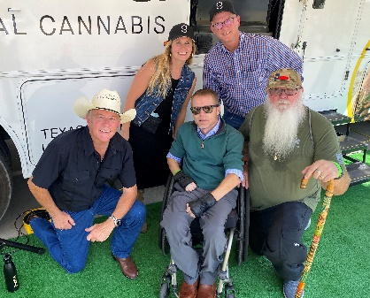
CTD began work with new partners, like our former board member Frank Santos and the Texas Patients First Foundation, to grow and improve the Texas Compassionate Use Program (TCUP). Our interim work to pave the way included a number of public speaking engagements and testifying at the Department of Public Safety Commissioners meeting on TCUP recommendations. Right, clockwise from left: Reece Fulgham, CEO of cannabis operator Parallel, Lynnette French, COO of Parallel, Gene Tallman, President of goodblend Texas, cannabis advocate David Bass, and our Chase Bearden at goodblend’s "Ride for Your Rights" CannaBus
Tour Austin stop.

Criminal Justice
Following up on successes of last year, we testified at an interim hearing on the progress of HB 30, which mandates that the Texas Department of Criminal Justice (TDCJ) provide a high school education to all minors who have been charged as adults in their custody. This includes making sure those who qualify for special education receive everything afforded to them under IDEA. In addition, we met with Rep. Johnson’s office to refile HB 3447, the county jail medical family liaison bill, which will increase transparency and agency in medical care for families of people with disabilities in county jails.

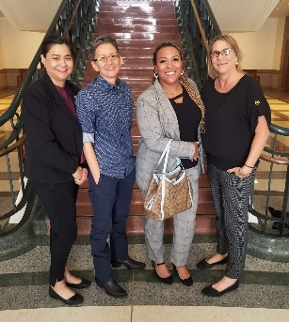
We testified at interim hearings on: TDCJ programming that is inaccessible for women with disabilities (right, Alexa Garza, EdTrust, our Jennifer Toon, Cynthia Simmons, Texas Center for Justice and Equity, and Lori Mellinger, Statewide Leadership Council), and the crisis at Texas Juvenile Justice Department (TJJD)’s 5 state facilities, which should be strategically closed with a plan to move kids into community care or build a new facility closer to urban areas.

In the Community
While legislative advocacy and work with state agencies are at the forefront of our efforts to build a barrier-free Texas, that’s not all we do. Our staff serves on dozens of workgroups, advisory councils, and boards. These include groups focused explicitly on disability issues, like REV UP Texas and the ECI Advisory Committee, and those who benefit from having a voice from our community at the table, like the Drug Utilization Review Board and the Texas After Violence Project.

At the grassroots level, we held 11 Raise Your Voice! Advocate Connection Program Zoom calls this year. Over 200 advocates and self-advocates from across the state joined us to learn, give input on CTD's advocacy work, and prepare to make our collective voices heard in 2023.

Our staff or work appeared in the media over 30 times in 2022, and we released several press statements responding to current events, including a word of caution to decision-makers against linking violence to mental health and disability, following the tragedy at Robb Elementary in Uvalde, Texas, and a call to the Department of Family and Protective Services to keep sight of their mission to protect Texas children, in the face of the Governor’s anti-trans directive.

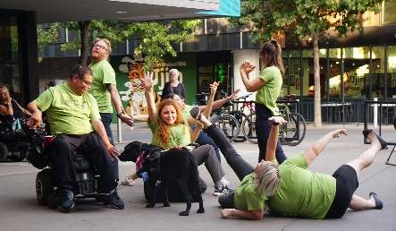
We were delighted to be in the theater again for our 19th annual Cinema Touching Disability Film Festival! All had a great time watching short film competition winners, this year's features, IMPERFECT and CRUTCH, and great performances from BodyShift (right), TILT, and CRUTCH star Bill Shannon!

Our virtual arts programming continued, with our monthly Lion & Pirate inclusive open mic, co-hosted by Art Spark Texas and Malvern Books, plus three incredible Thunder & Lightning Poetry Showcases spotlighting Disabled BIPOC and Disabled Queer Poets, with Art Spark Texas and poet Val Vera!

Finally, in our CDS Division, we completed a systems refresh to better serve consumers, a project years in the making. And, we organized a major consulting project on CDS best practices among providers across the state.

